SYST 17796 TEAM PROJECT
Team Name: BlackJack _____________________________________
  - Please negotiate, sign, scan and include as the first page in your Deliverable 1.

Team Contract
Please note that if cheating is discovered in a group assignment each member will be charged with a cheating offense regardless of their involvement in the offense. Each member will receive the appropriate sanction based on their individual academic integrity history.
Please ensure that you understand the importance of academic honesty. Each member of the group is responsible to ensure the academic integrity of all of the submitted work, not just their own part. Placing your name on a submission indicates that you take responsibility for its content.
Team Member Names (Please Print) | Signatures | Student ID
Project Leader:  Esosa Emokpae | 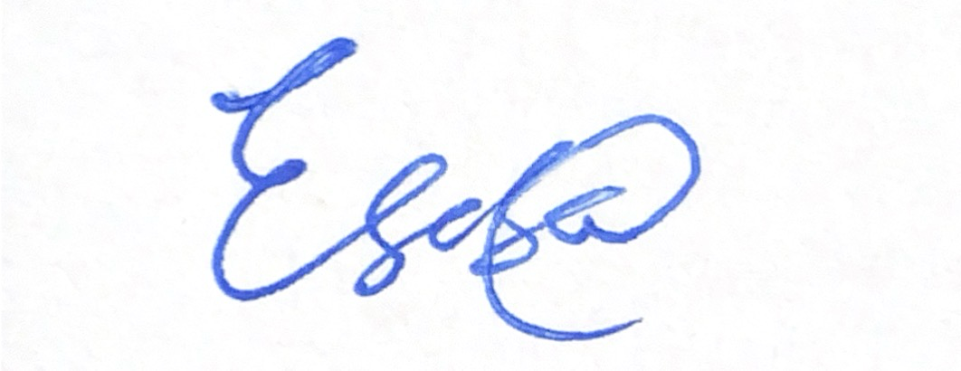 | 991717643
Jankat Erel | 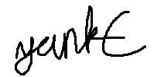 | 991802991
Ranbir Dhanki |  | 991852728
For further information, read Academic Integrity Policy here : https://caps.sheridancollege.ca/student-guide/academic-policies-and-procedures.aspx
By signing this contract, we acknowledge having read the Sheridan Academic Integrity Policy
Responsibilities of the Project Leader include:
- Assigning tasks to other team members, including self, in a fair and equitable manner.
- Ensuring work is completed with accuracy, completeness and timeliness.
- Planning for task completion to ensure timelines are met.
- Notifying the professor of any issues in a timely manner so that corrective measures can be taken.
- Any other duties as deemed necessary for project completion.

What we will do if . . .
Scenario | Accepted  initials | We agree to do the following  (Put an X corresponding to your choice in each box)
Team member does not regularly attend team meetings and/or does not respond to communications in a timely manner. | E.E  J.E  R.D | Project leader emails the student citing the concerns and cc’s the professor so they are aware of the situation at the very onset _X_ (Mandatory).  a) __ In addition to above, the leader/team will (add your own content here):
Team member does not deliver component on time due to severe illness or extreme personal problem. | E.E  J.E  R.D | a) Team absorbs workload temporarily __  b) Team seeks advice from professor _X_  c) Team shifts target date if possible __  d) __ Other (specify):
Team member has difficulty delivering component on time due to lack of understanding or ability. | E.E  J.E  R.D | a) Team reassigns component __  b) Team helps member _X_  c) Team member must ask professor for help __  d) __ Other (specify):
Team member does not deliver component on time due to lack of effort. | E.E  J.E  R.D | a) Team absorbs workload __  b) Team member(s) ask professor to request a Participation Form from all team members. This may result in individualized grades being awarded for a deliverable __  c) Both a. and b. above _X_  d) __ Other (specify):
Team cannot achieve consensus leaving one or more member(s) feeling that their voice(s) is/are not being heard in a decision which affects everyone. | E.E  J.E  R.D | a) Team agrees to abide by majority vote _X_  b) Team seeks advice from the professor __  c) __ Other (specify):
Team members do not share expectations for the quality of work on a particular deliverable. | E.E  J.E  R.D | a) Team members will draw on each other’s strengths to help bring the quality of the deliverable to a minimal acceptable level __  b) Team votes on each submission's quality __  c) Team member(s) ask professor to request a Participation Form from all team members, which may result in individualized grades being awarded for a deliverable __  d) _X_ Other (specify): a and c
Team member behaves in an unprofessional manner, e.g. being rude, uncooperative and/or making one or more member(s) feel uncomfortable. | E.E  J.E  R.D | a) Team agrees to avoid use of all vocabulary inappropriate to a business/college setting __  b) Team attempts to resolve the issue by airing the problem at a team meeting __  c) Team requests a meeting with the professor to discuss further __  d) _X_ Other (specify): b and c
There is a dominant team member who insists on making all decisions on the team's behalf leaving some team members feeling like subordinates rather than equal members | E.E  J.E  R.D | a) Team will actively solicit consensus on all decisions which affect project direction by asking for each member's decision and vote _X_  b) Team will express subordination feelings and attempt to resolve issue __  c) Team seeks advice from the professor __  d) __ Other (specify):
Team has a member who refuses to participate in decision making but complains to others that s/he wasn't consulted | E.E  J.E  R.D | a) Team forces decision sharing by routinely voting on all issues __  b) Team routinely checks with each other about perceived roles __  c) Team discusses the matter at team meeting _X_
Any other items/issues – use as many rows as needed

